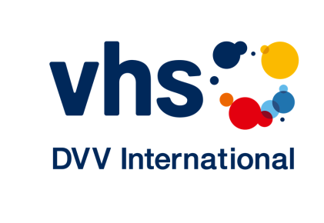

AED 85/2018: Call for Stories on the Role and Impact of Adult Education

Our journal Adult Education and Development (AED), issue 85/2018, is looking for stories/examples on “the role and impact of adult education” to be published in the form of short interviews in the next issue.

If you are an adult educator, a learner, a researcher, a project manager or a policy-maker and have something to say about “the role and impact of adult education”, please share your stories/thoughts/experiences with our readers worldwide.

We are looking for your stories/thoughts/experiences in the following areas:
- The impact of adult education on your personal life or the life of your community;
- Examples of good practices (impact of adult education projects, successful tools for project designing to ensure impact, innovative methods of monitoring of impact, etc.);
- Results of studies on impact, monitoring, measurement or others;
- The role and/or impact of adult education in a specific sector or in a country.

If you want to share your story, please send us your suggestion and some further information:
Your name:
Your organisation, function:
Your email:
Your story/topic in two or three sentences:

Based on your suggestions, the editorial team will make a selection and get back to you with three interview questions. Your answers will be published together with a portrait picture in the next issue (print and/or online).

Please send your answers to:
Johanni Larjanko (johanni.larjanko@gmail.com) and Ruth Sarrazin (sarrazin@dvv-international.de)

Suggestions can be submitted in English, French and Spanish. The deadline is April 20, 2018.

Thank you for your help!

