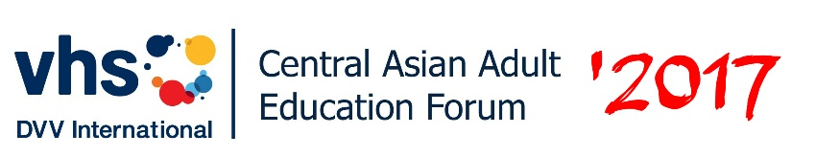
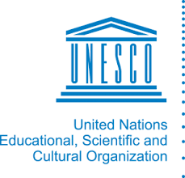

CALL FOR ACTION
Promoting lifelong learning through
Community Learning Centers

- We, the participants of the Central Asian Adult Education Forum "Community Learning Centers: International Trends and Best Practices", gathered in Issyk-Kul Lake in the Kyrgyz Republic from September 7 to 9, 2017 in order to promote and strengthen the role of the Community Learning Centers (CLC) with the purpose of expanding access to quality learning for all and thus contribute to the well-being of local communities;
- We acknowledge that every individual today must cope with a number of such challenges as combating poverty and conflicts, promoting diversity and equality, ensuring sustainable economic growth and decent work, climate change, urbanization, violence, and others. All these require continuous training, preparedness and relevant response. CLC, through flexible curriculum models, are designed to play an increasingly important role in addressing these problems by assessing individual needs and creating a structured learning environment throughout life within communities;
- We reaffirm that flexible education models (which include adult education and non-formal education) help to fill the gaps in lifelong learning, thereby, ensuring the implementation of the fourth Sustainable Development Goal (SDG-4) on access to quality education and lifelong learning for all and contributing to the achievement of the remaining sixteen SDGs;
- We emphasize that CLCs are multi-purpose learning spaces of local communities that facilitate the wide-scale participation of all stakeholders in adult education as integral components of a lifelong learning system;
- We join the appeals of the international community to critically evaluate and assess the existing national education systems for the development of comprehensive models and to encourage flexible approaches to lifelong education / training as to approach the place of residence, taking into account the principles of quality, justice and equity;
- In view of the abovementioned, we call for the following actions:
- Improve existing national legislations by including specific sections and paragraphs to promote the creation of CLCs or enhance their capacity, where they already exist, in order to provide lifelong learning opportunities for all and to acquire the skills and competencies of the twenty-first century, including global citizenship and sustainable development;

- Revise the legislative framework to harmonize the used terms and the importance of adult education and learning and lifelong learning based on the UNESCO Recommendation on Adult Learning and Education;
- Establish a public administrative body / structure with maximum involvement of stakeholders to promote the development of the adult education sector;
- Raise the awareness of policy-makers, representatives of local authorities, the private sector and civil society about the importance of CLCs in the sustainable development of local communities and in attracting public, community and other resources to support and for their development;

- To contribute to the improvement of the quality of CLC activities through the provision of sufficient resources including support for the continuous improvement of the skills of their personnel;

- To support socially vulnerable groups of the population with a view to realizing their rights to education, social adaptation and improving living standards, including through CLCs;
- Initiate the implementation of programs and activities that promote social partnership, and develop different approaches and models for partnerships;
- To increase the exchange of knowledge and cooperation between CLCs and various governmental, non-governmental, private and international organizations through networking, the creation of public consultation boards and other forms of partnerships.
Issyk-Kul, the Kyrgyz Republic, 9 September 2017

